## Create the Slip Lane

1. Select the **Turn Lane** tool from the Roads tab and create a diagonal road as shown below.

* 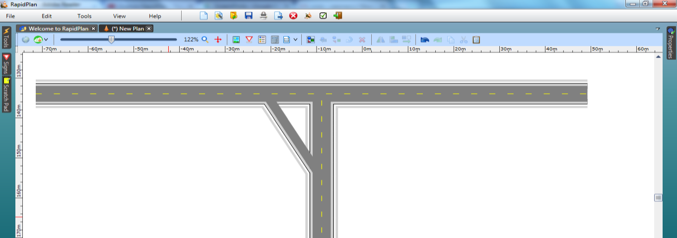
* Slip_Lanes_Intersection_step_2

1. Move half way along the Turn Lane, right click and select **Insert control point**. Move the control point to shape the road to a fluid curve as shown.

* 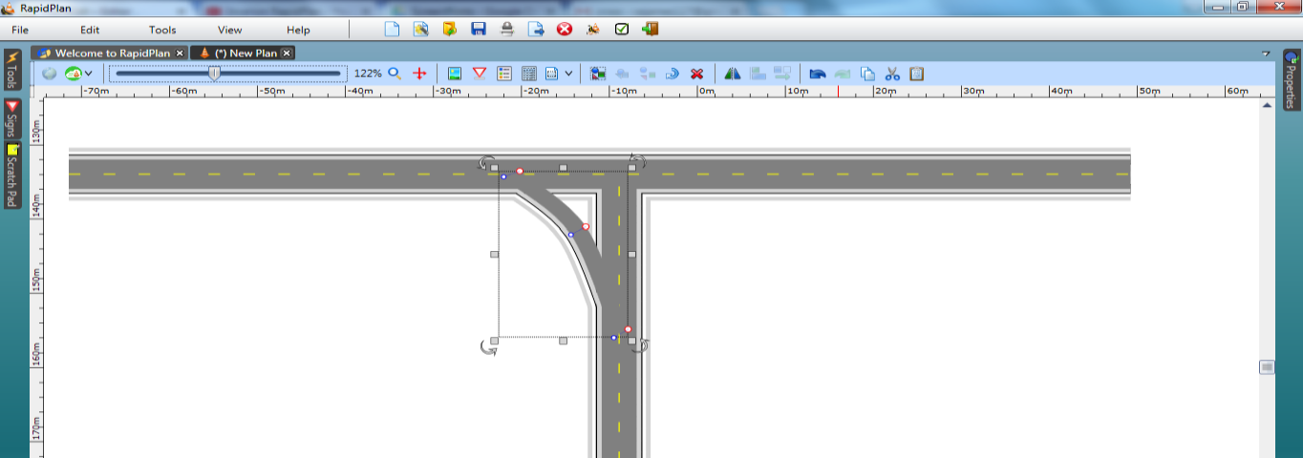
* Slip_Lanes_Intersection_step_3

1. Add any necessary pavement markings.

* 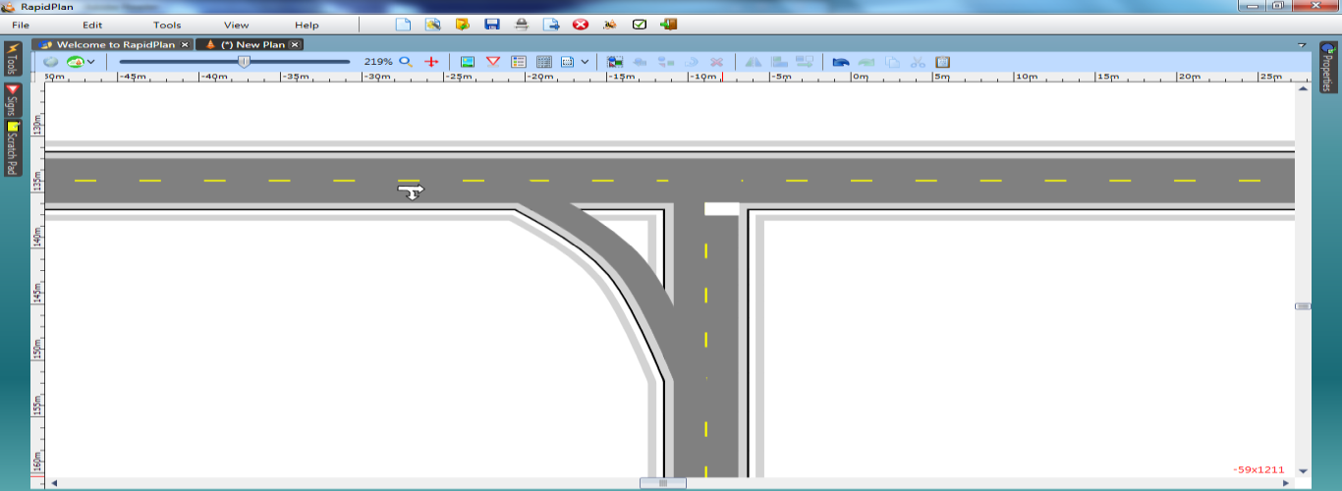
* Slip_Lanes_Intersection_step_4